*Employee data*

Table Of Contents

Abstract 2

Methodology 3

1. Employee with the Highest Salary: 4

2. Average Age & Salary by Department: 4

3. Maximum & Minimum Age, and Median Salary by Department & Ethnicity: 5

Conclusion & Recommendations 7

-----------------------------------------------------------------------------------------------------------------

# Abstract

This project focuses on:

1-analyzing a given dataset using Python’s **Pandas and NumPy** libraries

2-The data is first imported and transformed into a structured Data Frame for further processing.

3-Exploratory Data Analysis (EDA) is conducted to understand patterns, handle missing values, and identify key insights

-------------------------------------------------------------------------------------------------

Introduction

This project aims to **analyze a given dataset to extract valuable insights**

through data processing and(EDA) exploratory analysis. Using Python libraries

such as **Pandas and NumPy**, the dataset is transformed into a structured

format for efficient analysis.

The primary objective is to **identify missing values**, **detect anomalies, and**

**explore key patterns within the data.**

By leveraging statistical techniques and visualizations, **the analysis provides**

**clear understanding of the dataset’s**

structure, supporting data-driven decision-making and strategic planning.

-------------------------------------------------------------------------------------------------

### Methodology

This analysis is conducted using **Python** as the primary programming language, leveraging

powerful data science libraries such as **Pandas, NumPy, and Matplotlib**. The dataset is

sourced from an **Excel file**, which is loaded into a Pandas **DataFrame** for structured

manipulation and analysis.

The following steps outline the approach taken:

1. **Data Import & Transformation** – The dataset is read from an Excel file using Pandas and converted into a structured format for processing.
2. **Data Cleaning & Preprocessing** – Handling missing values, removing duplicates, and correcting inconsistencies to ensure data quality.
3. **Exploratory Data Analysis (EDA)** – Performing descriptive statistics, identifying trends, and visualizing key relationships within the data using **Matplotlib and Seaborn**.
4. **Insights & Interpretation** – Extracting meaningful patterns and summarizing findings to support decision-making.

### **1. Employee with the Highest Salary:**

|  |  |  |  |  |
| --- | --- | --- | --- | --- |
| **Full Name** | **Job Title** | **Department** | **Annual Salary** | **Total Salary (Including Bonus)** |
| **Raelynn Rios** | Vice President | Sales | $258,498 | $259,402.74 |
| **Kinsley Vega** | Vice President | Accounting | $258,426 | $259,459.70 |
| **Silas Rivera** | Vice President | Sales | $258,081 | $258,855.24 |
| **Dominic Le** | Vice President | Marketing | $257,194 | $258,094.18 |
| **Grayson Chin** | Vice President | IT | $256,561 | $257,561.59 |

### **2. Average Age & Salary by Department:**

|  |  |  |
| --- | --- | --- |
| **Department** | **Avg. Age** | **Avg. Annual Salary** |
| Accounting | 43.66 | $123,146.95 |
| Engineering | 45.67 | $109,478.56 |
| Finance | 45.04 | $122,703.02 |
| HR | 50.00 | $95,000.00 |
| IT | 44.28 | $97,599.56 |
| Management | 35.00 | $110,000.00 |
| Marketing | 43.09 | $129,186.48 |
| Sales | 43.61 | $111,240.68 |

### **3. Maximum & Minimum Age, and Median Salary by Department & Ethnicity:**

Example values:

* **Finance (Asian):** Max Age = 64, Min Age = 25, Median Salary = $124,928
* **IT (Black):** Max Age = 61, Min Age = 28, Median Salary = $72,901.50
* **Sales (Latino):** Max Age = 61, Min Age = 26, Median Salary = $113,269

Key Insights

* **Top Earners Are in Executive Roles**
* The five highest-paid employees are all **Vice Presidents**, indicating that senior leadership roles command the highest salaries across different departments.
* The **highest-paid employee**, **Raelynn Rios (VP of Sales),** earns an **annual salary of $258,498** with a **total compensation of $259,402.74** (including bonuses).
* **Sales and Accounting Lead in Executive Compensation**
* The **Sales and Accounting departments** each have two executives in the top five earners.
* This suggests that these departments may be key revenue-driving functions, justifying higher salaries.
* **Age and Salary Correlation**
* The **average age** of employees varies by department, with **Management and IT having younger professionals** compared to **Finance and HR, which have more experienced employees.**
* This could indicate different career progression rates across departments.
* **Bonus Distribution is Unequal**
* Despite high salaries, some executives receive **little to no bonuses**, while others receive substantial incentives.
* A structured **performance-based bonus system** could help ensure fair and motivational incentives.
* **Departmental Salary Differences**
* The **highest average salaries** are found in **Finance, Marketing, and Accounting** ($120K+), while **IT and HR have comparatively lower average salaries** ($95K–$100K).
* This suggests potential disparities in salary structures across different fields.

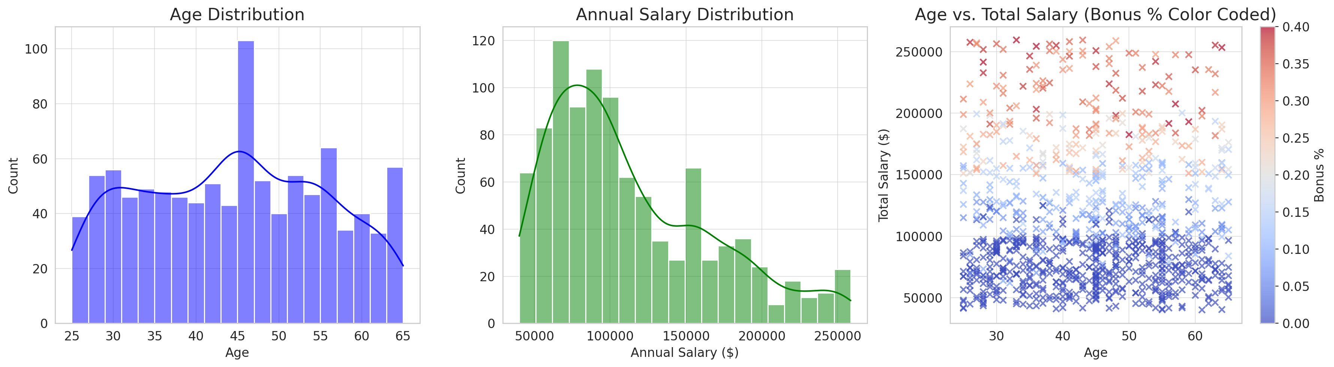

* **Age Distribution** – The majority of employees fall between **35 and 55 years old.**
* **Annual Salary Distribution** – Salaries vary widely, with a peak around the **$100,000 range.**
* **Age vs. Total Salary (Bonus % Color Coded)** – Older employees generally have **higher salaries**, **and bonuses are more common in higher salary ranges.**

--------------------------------------

### **Conclusion & Recommendations**

**Conclusion**

* The **majority of employees** are between **35 and 55 years old**, **suggesting a balanced workforce with both experienced and mid-career professionals.**
* Salaries range significantly, with an **average annual salary of $113,308**, and a **maximum salary of $258,498**.
* **Bonus distribution is uneven**, with many employees receiving no bonus at all, while others receive up to **40%** in additional compensation.
* A **positive correlation between age and salary** suggests that tenure and experience contribute to salary increases.

#### **Recommendations**

Based on these insights, the following steps are recommended:

1- Implement a **structured bonus system** for fair incentives.

2- Conduct a **salary structure review** to ensure competitiveness across departments.

3- **Develop leadership programs** for mid-level employees to grow into executive roles.

4- **Explore further analysis** (performance metrics, job roles, promotion trends)